CARDIFF METROPOLITAN UNIVERSITY
ICBT Campus, Sri Lanka
BSc (Hons) Software Engineering
CIS6003 Advanced Programming
WRIT1: Individual Written Report

Sunrise Dental Clinic
Appointment and Patient Management System

Submitted by
W.A. Gangul Kalhara Rathnayake
Student ID: st20360306
Repository: https://github.com/OGGY404/sunrise-dental-clinic
September 2026

Table of Contents
1. Introduction 2
2. Task A: System design with UML 3
2.1 Use case model 3
2.2 Class model 5
2.3 Sequence models 7
2.4 Documented assumptions 10
2.5 Critical evaluation of the design 10
3. Task B: Development 12
3.1 Three-tier architecture 12
3.2 Distributed application with web services 12
3.3 Design patterns 13
3.4 The database and its advanced features 14
3.5 Validation, sessions and security 16
3.6 The user interface 17
3.7 Additional functionality delivered 19
4. Task C: Testing 21
4.1 Rationale for the testing approach 21
4.2 How test-driven development was used 22
4.3 Test plan and test data 23
4.4 Test automation and results 24
4.5 Traceability matrix 25
4.6 Evaluation and lessons learned 26
5. Task D: Git and GitHub 27
5.1 Repository and branching strategy 27
5.2 Commits across multiple days 27
5.3 Continuous integration and deployment 28
6. Conclusion 30
References 31
Appendices 32

1. Introduction
The Sunrise Dental Clinic is a private dental clinic in Colombo where its schedules and files were recorded in writing. There are three repercussions mentioned in the scenario: double booking, missing files, and incorrect billing. These are simply three manifestations of one flaw, as the paper diary cannot ensure a rule.
This report covers the new computerized system replacement: the three-tier Java application implemented on Spring Boot 3 and MySQL 8, including the REST web services and seventeen Thyme leaf interfaces that satisfy six main functional requirements and thirteen additional ones listed in the brief. This application is thoroughly tested by 268 automated tests, eight UML diagrams and a pipeline for its building, testing and deployment. The four components to be evaluated come next; all code, diagrams and documentation can be found in the repository above.

2. Task A: System design with UML

2.1 Use case model
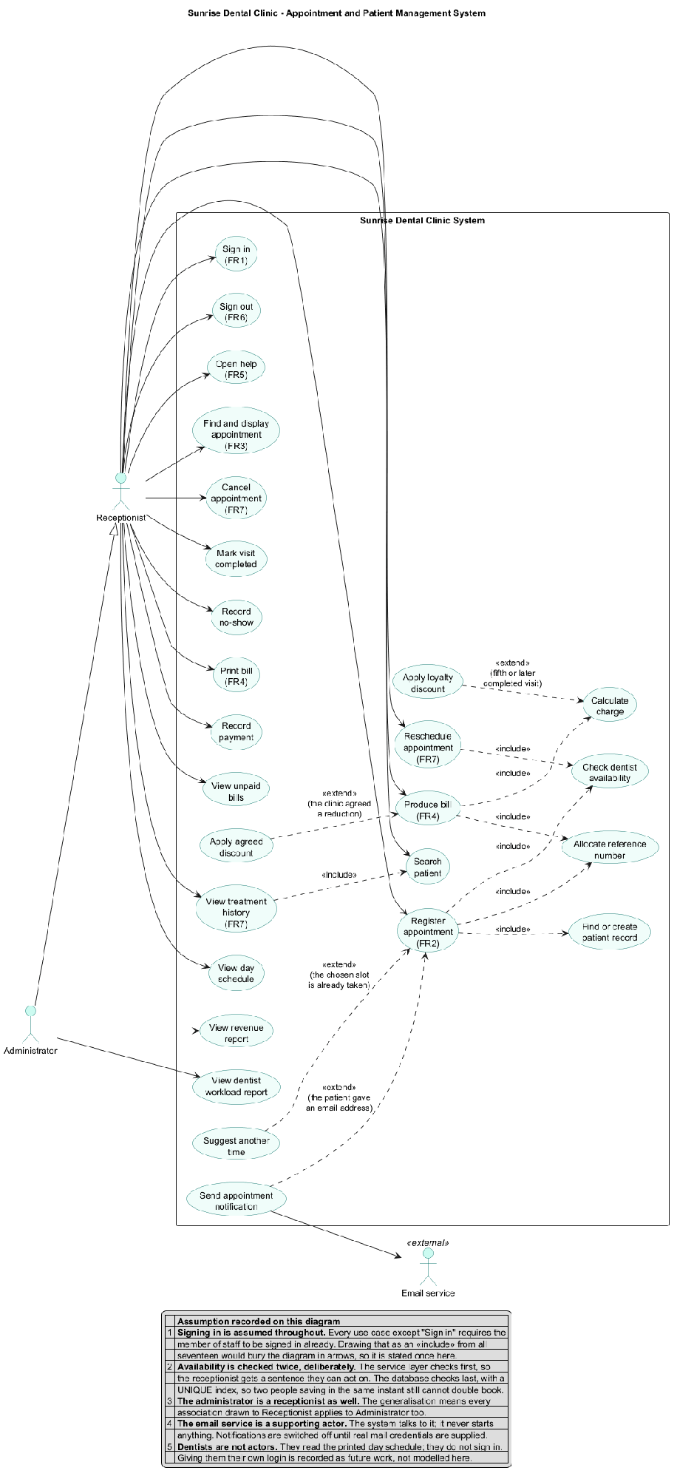
Figure 1: Use case diagram
Two humans act as actors within the system. The Receptionist is the one who carries out day to day tasks and the Administrator is depicted as a generalization of the Receptionist since an administrator does all the things that a receptionist does as well as viewing the management reports; the generalization ensures that all associations need to be depicted just once.
Email service acts as a supporting actor in that the system communicates with it but it never initiates anything. Dentists are intentionally not actors in the system since they view the day’s printed schedule and do not log in. Providing dentists a login is documented as future work.
The stereotypes of <<include>> and <<extend>> are used in their appropriate forms, which are antonyms and are often confused.
- An include is an action that is performed by the base use case each and every time, extracted since more than one use case requires it. Appointment registration include Find or create patient record, since there cannot be an appointment without a patient. The arrow goes away from the base use case.
- An extension will take place sometimes depending on whether certain conditions are met; the arrow goes back to the base use case and is not aware that such an extension has taken place. Propose another extend of Register appointment when the chosen slot is taken.Four includes and four extends are modelled, each labelled with its condition.

2.2 Class model
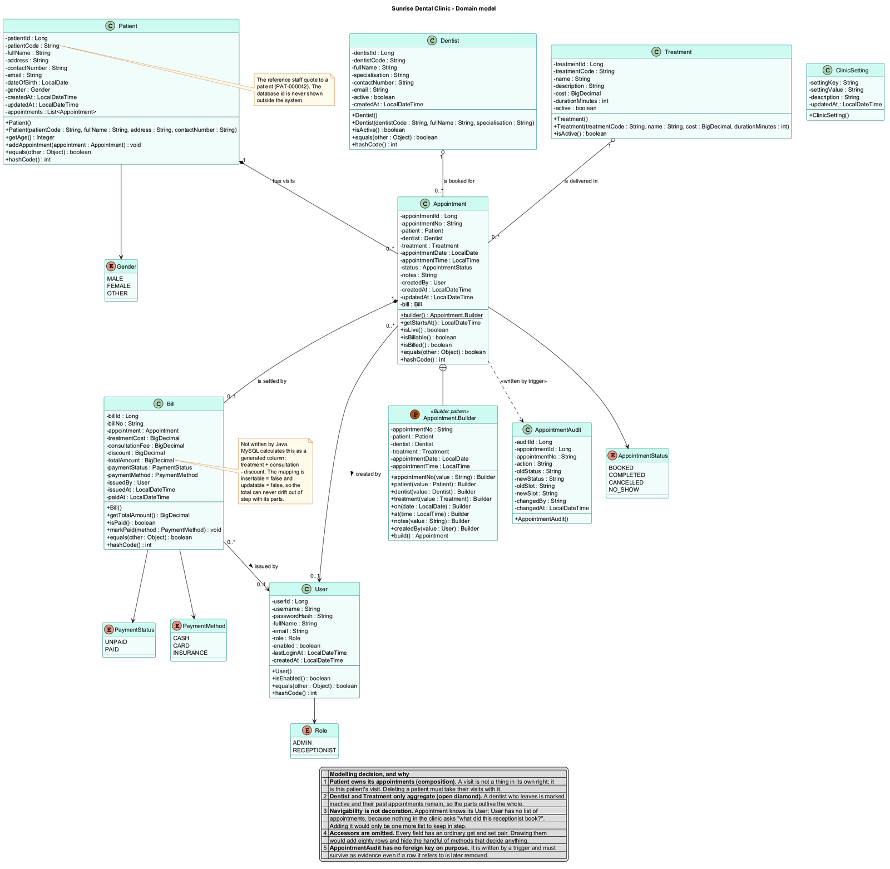
Figure 2: Domain class diagram
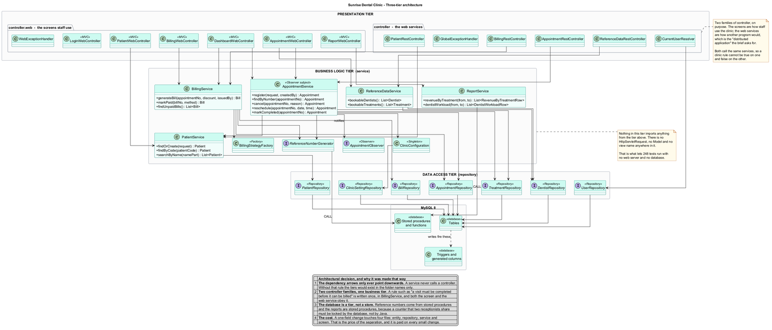
Figure 3: Three-tier class diagram
In Figure 2, each field has its type, and every method has its full signature, which has been copied from the source, not recalled. All the fields have been made private with the accessors as public.
Whole part relationships were the most challenging, and the two types have different uses for specific purposes:
- Composition (filled diamond) connects Patient to Appointment and Appointment to Bill. An appointment does not exist as an entity by itself; rather, it is a visit from this particular patient, and has no significance without the patient. The bill only exists as a payment for that particular visit.
- Aggregation (open diamond) connects Dentist and Treatment to Appointment. The distinction is that these components have a longer lifetime than the whole because an inactive dentist is flagged after they leave the clinic, but the appointments never get removed from the database.
Multiplicity is expressed on all associations. In Appointment 1 ↔ 0..1 Bill, the 0..1 multiplicity is the feature which allows a visit to occur but not to be billed yet.
Navigability depends on the code and not on beautifying the diagram. Appointment knows its User, but User does not have any collection of appointment since nothing in the clinic cares to ask, "What did this receptionist book?". Figure 3 organizes the same classes into tiers and the one message is that all arrows in dependencies point downwards.

2.3 Sequence models
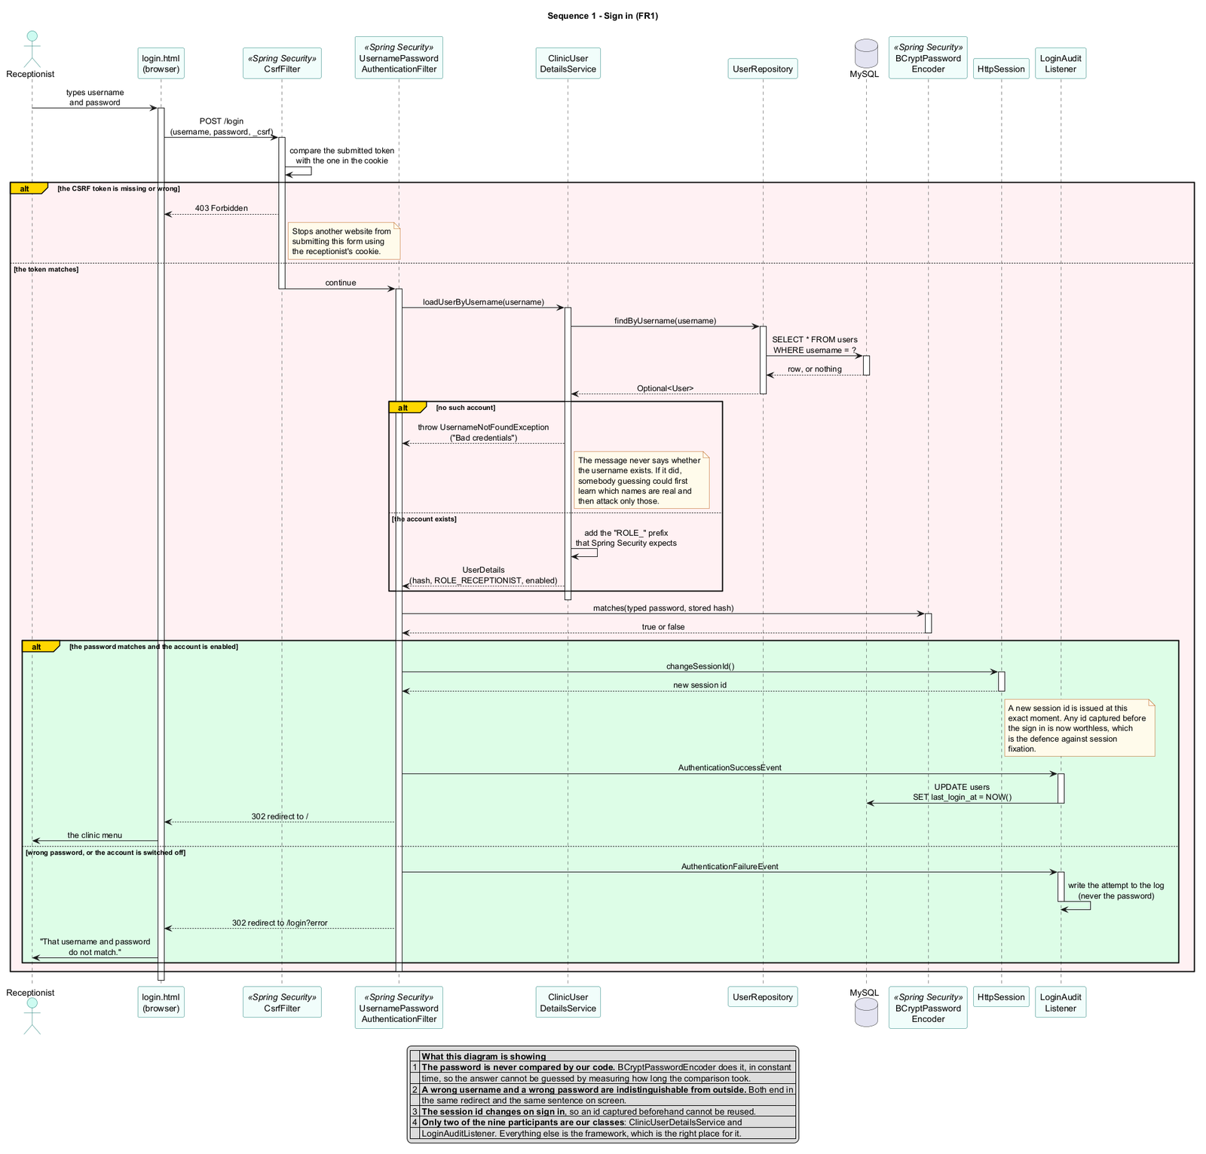
Figure 4: Sign in
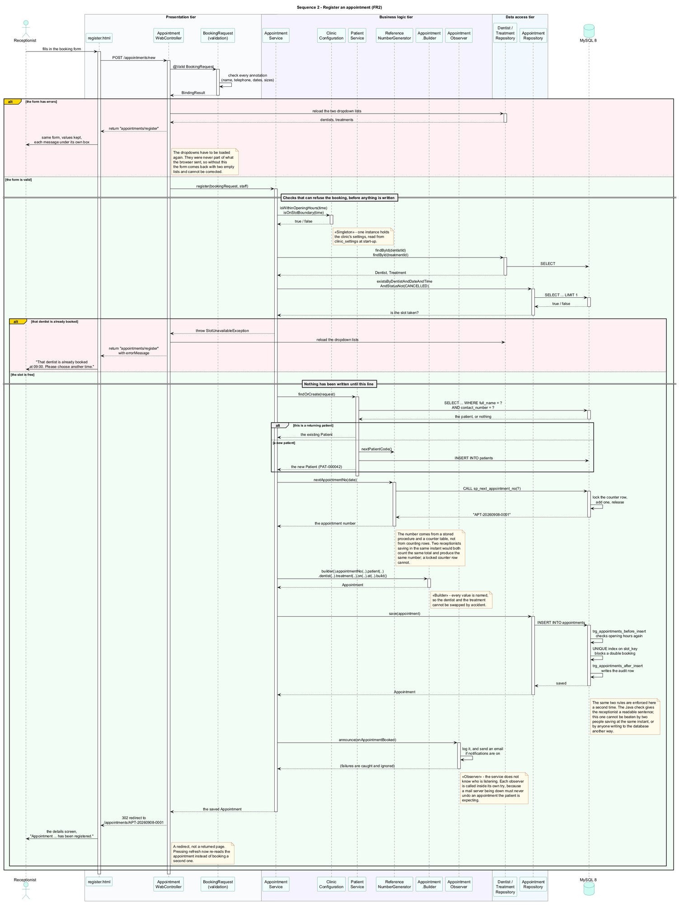
Figure 5: Register an appointment
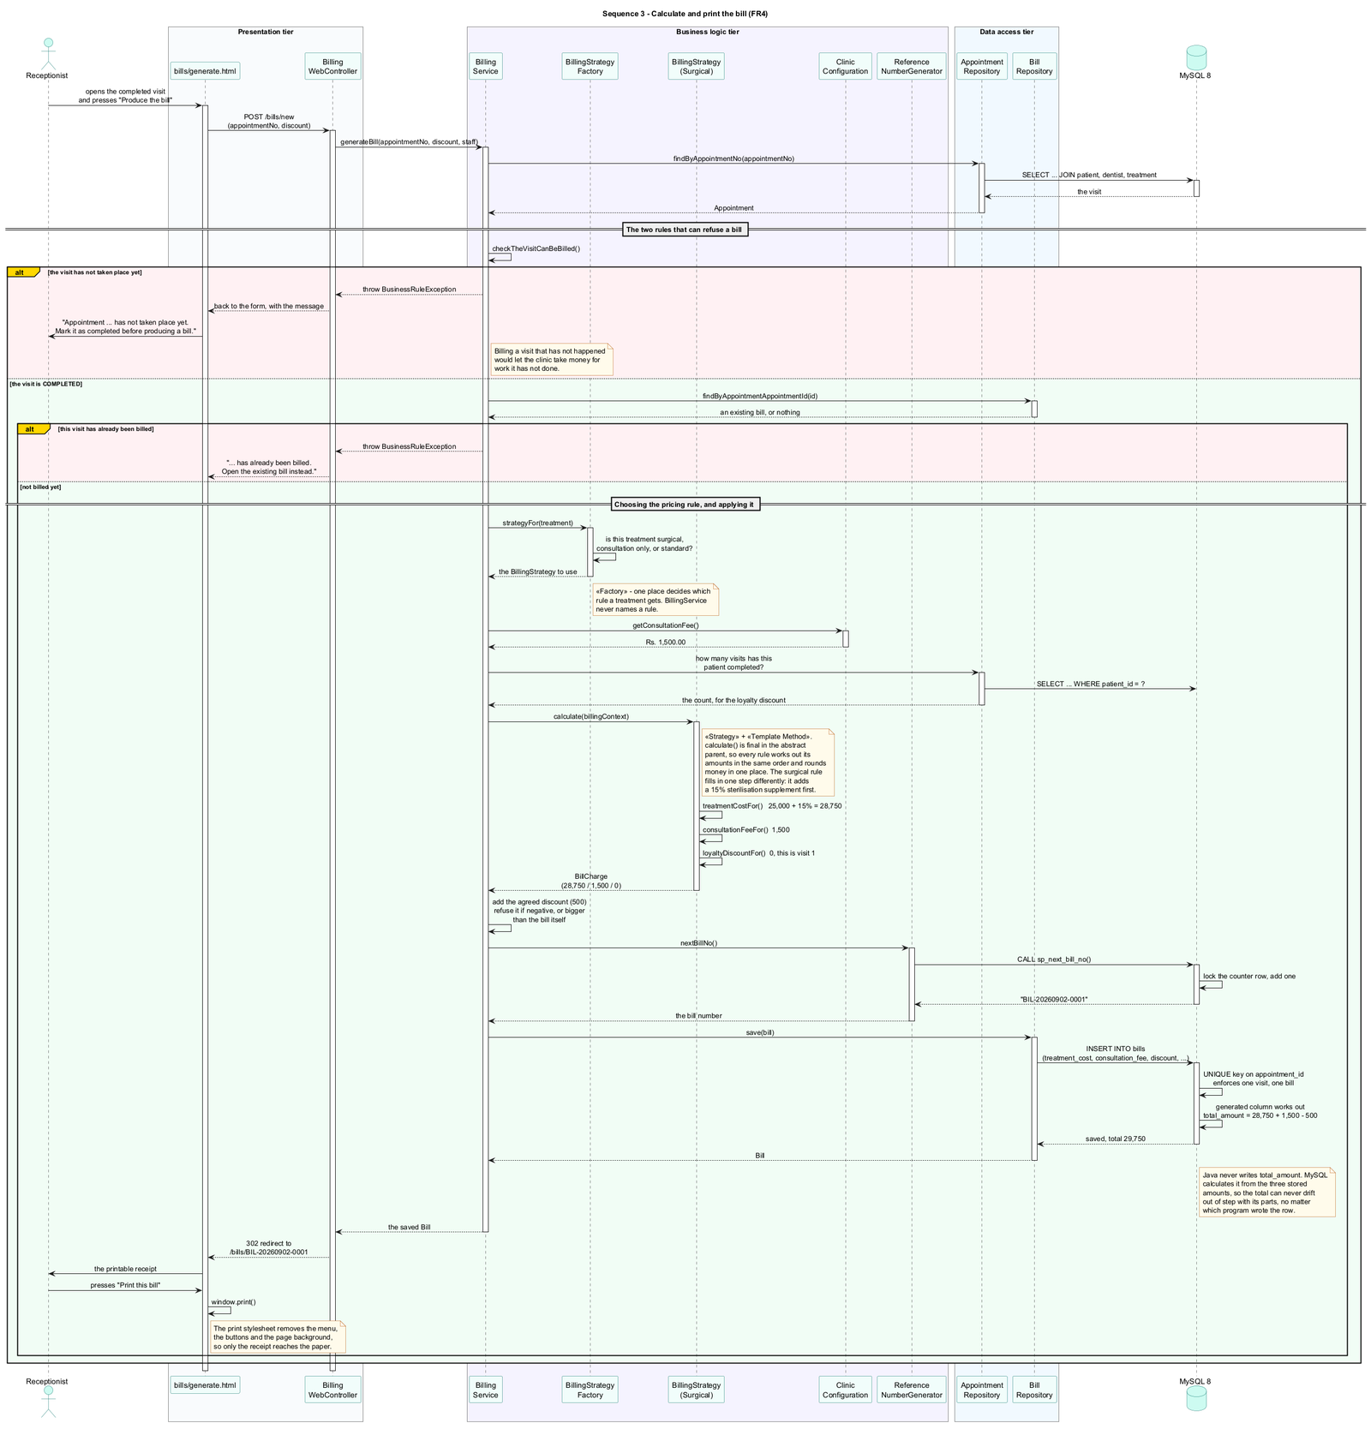
Figure 6: Calculate and print the bill
There were four sequence diagrams created; three out of them can be seen in Figures 4 to 6 while the fourth one (the cancellation) is available in Appendix E. They all have lifelines, activation bars and alt fragments. There are three things worth noting that are not just about arrows.
The individuals in Figures 5 and 6 are sorted into tiers bands, and communications happen from top to bottom only, which means that the architecture presented in Figure 3 is recognizable in a particular form. The alt alternatives demonstrate how the paths for failure have been designed rather than discovered since Figure 5 consists of three different outcomes (incorrect form, slot missing, booking successful), all of which have been designed prior to writing the corresponding piece of code. Lastly, the comment “Nothing has been written until this line” is indicative of the deliberate order of operations because all rejections come prior to creating the rows.

2.4 Documented assumptions
There were seventeen assumptions made during the modelling process; these can be found in Appendix D. The five most important to the design of the process include the assumption that the patient does not use the system personally; that one dentist will see one patient at a time, meaning that dentist date-time will be unique; that the returning patient will be identified on the basis of his/her name and telephone number because the name will be common between two individuals and the number common between the family members; that the visit will generate only one invoice and the prices will be copied onto it when it is issued to ensure the survival of the receipt beyond the increase in prices; and that cancellations free up the appointment whereas the no shows do not since the dentist's time has been wasted anyway.
There are two additional assumptions which are limitations rather than choices. The fact that a prolonged treatment will not yet preempt the next slot is true despite recording its own length, and some rules are applied twice, once in Java and once in SQL, as explained in §2.5.

2.5 Critical evaluation of the design
All three diagram types agreed on this, and I verified one such path myself. The use case of register appointment can be seen in Figure 1; its classes are shown in Figures 2 and 3 while the message flow is in Figure 5. They differed on the issue of navigability, where the class diagram I drew first showed User having a collection of appointments, but none of the sequence diagrams ever did this.
The most difficult choice was to apply some rules twice, once in Java code and again in SQL. I decided to keep both. Having one check in Java provides the secretary with a rule that can be followed, while having one check in the database prevents anyone from beating it, even if two users save at the same time. This is not free, since there are now two copies of a rule that might diverge, but I'd do it again.
The weakness in the design is in regard to the treatment time. The time for each treatment is tracked, but in case of a lengthy treatment, it doesn’t yet lock out the next period of time. This was realized during the creation of the class diagram.

3. Task B: Development

3.1 Three-tier architecture
The code includes controller, service, and repository packages, along with model, dto and config packages, and one single rule applies to everything dependencies are only downward facing, which is the layering Fowler (2002) describes. There is nothing like HttpServletRequest, no Model and no view names in the business tier.
The proof here is not in package names but in the test coverage: out of 268 test cases, 262 run without a MySQL installation, which is made possible because the separation between the tiers is real. The 92 classes under src/main contain 6 services, 3 billing strategies, a factory, 4 notification and a configuration holder in the business tier.

3.2 Distributed application with web services
There are seventeen REST endpoints in the web service layer, built with the annotated controllers of the Spring framework (VMware, 2024a), making this a distributed application instead of a desktop monolith.
These include the creation, display, cancellation, rescheduling, and completion of a visit; patient search and treatment history; bill generation, reading, and settlement; and the two reference lists that the booking form requires. These are enumerated in Appendix I.
Two classes of controllers instead of one for the business layer have been deliberately used here: the regular controller returns JSON output for applications, and the .web controller returns HTML output for people. The two controllers use the same service layers, ensuring that a constraint like “A visit has to be completed before it is billed” does not become inconsistent across both interfaces.

3.3 Design patterns
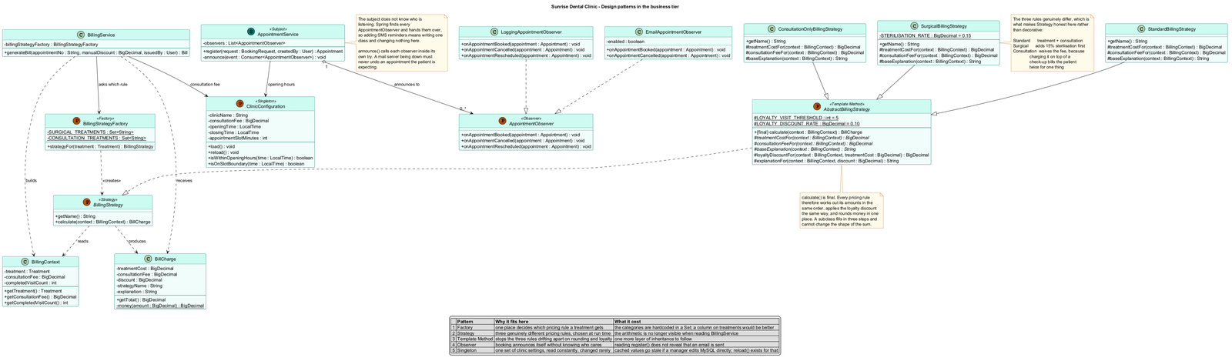
Figure 7: Design pattern class diagram
Eight patterns from the catalogue of Gamma et al. (1994) have been employed (Figure 7). Each one is identified through comments in the code, along with the improvement it brings and its cost since any pattern without a cost would normally not have been considered.
Pattern | Where | What it improved | What it cost
Singleton | ClinicConfiguration | an example of how settings in the clinic are; read often and rarely changed | Values cached become out-of-date when a MySQL manager makes any changes to the database; this is where reload comes into play.
Strategy | three billing rules | pricings made during execution time when BillingService doesn't specify any rule | There is nothing in BillingService to suggest the arithmetic involved
Template Method | AbstractBillingStrategy | The method calculate() is final, which means that all three policies follow the same sequence and round off money only once. | one additional layer of genetics to trace
Factory | BillingStrategyFactory | One body makes decisions on the classification of the therapy | treatment types are hardcoded into a Set; it would be better to use a database field
Builder | Appointment.Builder | All values are labeled; therefore, dentistry and treatment cannot be confused by mistake. | about 40 additional lines, and another place to update
Observer | AppointmentObserver, ReminderNotifier | Booking introduces itself without even knowing the listener; SMS integration adds one extra class. | register() does not tell you that the email is being sent
Repository | seven Spring Data interfaces | access to data is stated explicitly | The created SQL query does not appear in the code
MVC | controller.web + Thymeleaf | screens detached from regulations | two controller types to stay synchronized

Strategy is the pattern that does the most work in this system. All three of the pricing rules below really do differ:
- Standard: cost of the treatment + cost of the consultation.
- Surgical: includes 15 % sterilization surcharge to the cost of the treatment first (extraction, root canal, wisdom tooth).
- Consultation only: costs no consultation fee, as it would mean that the patient was charged twice for the same service (consultation).
This task could be accomplished in one pattern with an if, but all its branches would also have to include loyalty discount and rounding again.

3.4 The database and its advanced features
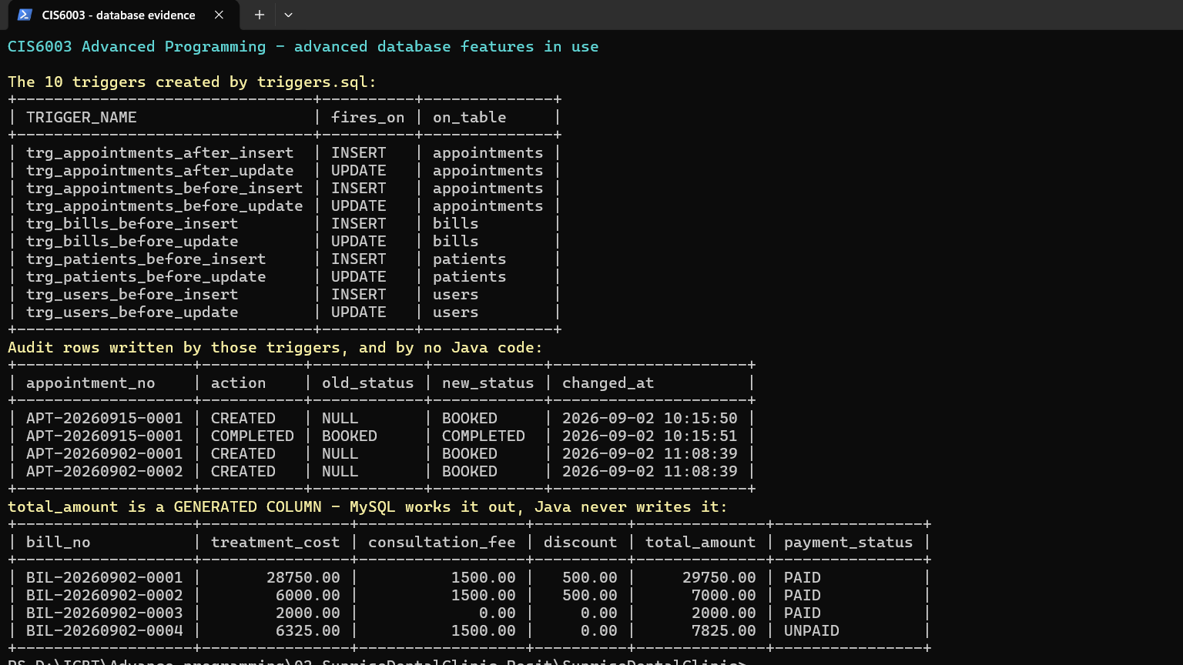
Figure 8: Database evidence
The schema consists of 1,750 lines of SQL in four scripts, which include 10 tables, 6 stored functions, 13 stored procedures, and 10 triggers created automatically at the very first run. There are four cases when the code works in a way Java explicitly avoids.

Reference numbers are generated by stored procedures. Counting existing rows and adding one fails in the case of two receptionists updating at exactly the same time; each counts the same number of rows and generates APT-20260908-0007. sp_next_appointment_no locks one row in the counter for the amount of time it needs, so each receives 0007 and 0008, respectively.
Double booking is avoided by a generated column. appointments.slot_key contains dentistId|date|time for a live appointment and NULL for a cancelled appointment, with a UNIQUE index on it. Since MySQL allows multiple NULL values in a unique index (Oracle, 2024), cancelling makes the slot available but does not delete anything, and the visit will remain in the patient's history.
Total cost is computed in MySQL. bills.total_amount is a generated column that computes treatment_cost + consultation_fee - discount, with insertable = false and updatable = false so that Java can't update it. It cannot go out of sync with its parts, regardless of which program updated the row.
Triggers keep a record that no one can edit silently. Ten triggers do both validation and auditing (Figure 8). Two triggers write to appointment_audit, and this is a table never written to by any Java program; now the clinic can tell “who booked this appointment, and when?” an impossible question on paper.
Five stored procedures are invoked by the running system, not just distributed with it: two for reference numbers, and three for generating reports and alerts.

3.5 Validation, sessions and security
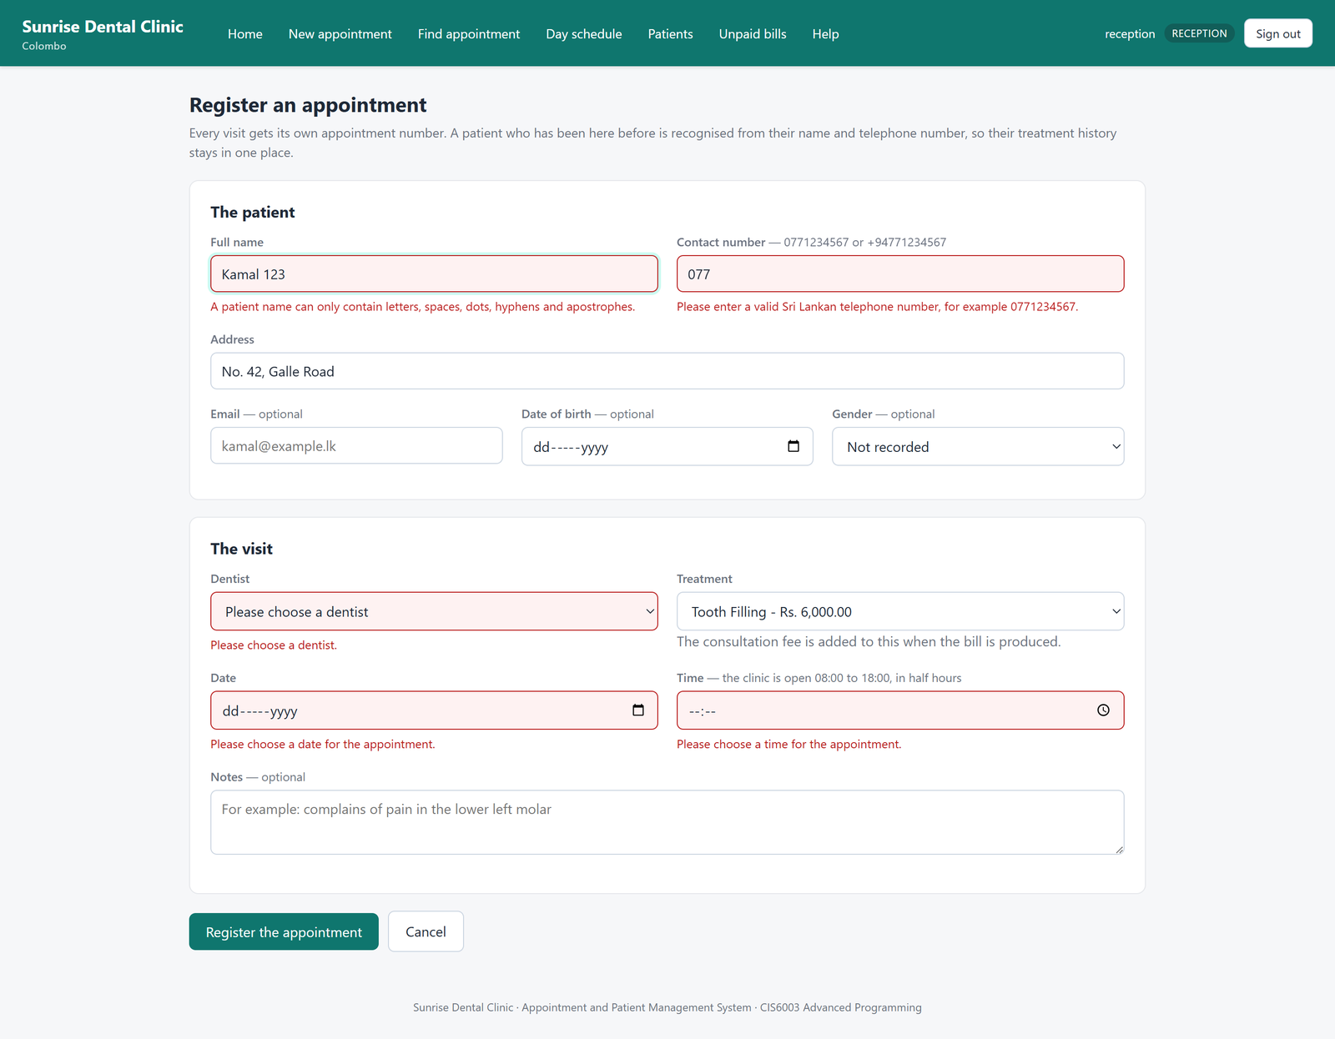
Figure 9: Validation
Bean validation annotations protect every incoming field, and every restriction corresponds to the column length in schema.sql; therefore, anything that gets validated can be saved. A phone number will be valid only in the format 0771234567 or +94771234567, and nothing else; a name can consist of letters, spaces, full stops, hyphens and apostrophes, but not digits. The regular expression allows W.A.G.K. Rathnayake-Silva, which was erroneously denied by the previous letters-only format.
See Figure 9 for a denial; the exact same form comes back, along with a message for each problematic field and a reload of the two dropdown menus. The receptionist will have to type everything again otherwise.
Sessions and cookies. Login status is maintained via an HttpOnly session cookie, called SUNRISEID and SameSite=Lax, which means the browser does not attach the cookie when another website sends a request to ours, and this is what blocks crosssite form attacks. It expires in thirty minutes, which could be important if someone walks away from his computer. A new session id is generated upon login, so an old one will be useless.
Cross-site request forgery protection is enabled, since saving login state in a cookie is what makes the attack possible (OWASP, 2024). The read operations require no tokens; all writes do.
Passwords are BCrypt hash values at work factor 10, compared by BCryptPasswordEncoder in constant time by Spring Security (VMware, 2024b), not any code written in this project. A bad username and a bad password will both be refused, so no user can figure out which usernames are registered. Role-based access control distinguishes between ADMIN and RECEPTIONIST: the reports show clinic-wide revenues, and the receptionist gets 403.

3.6 The user interface
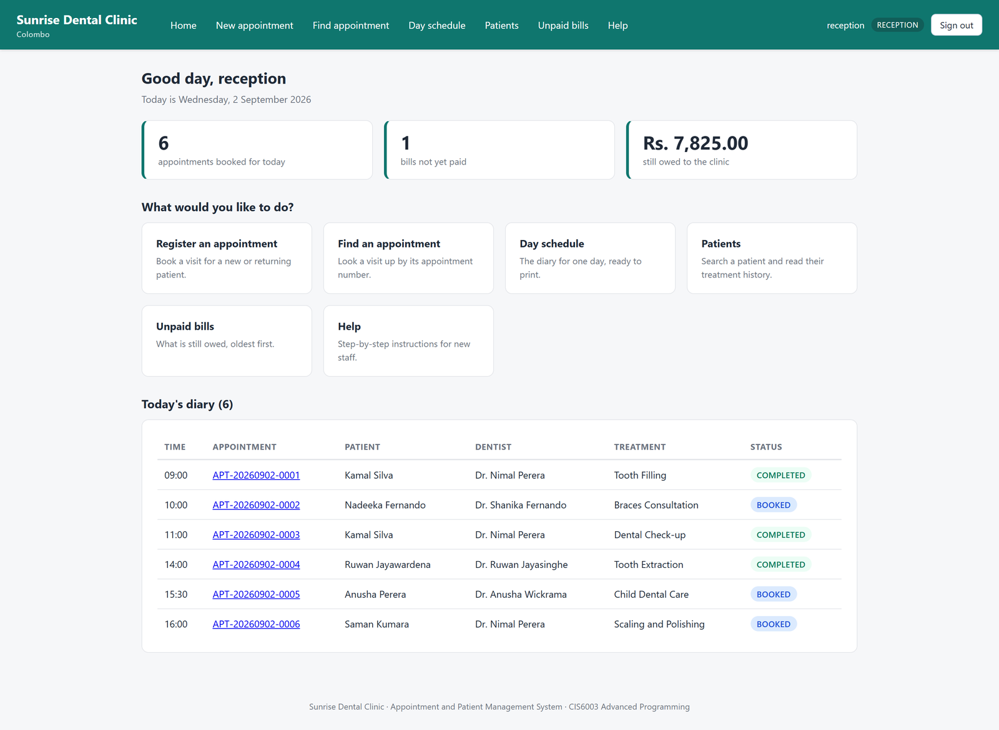
Figure 10: Main menu
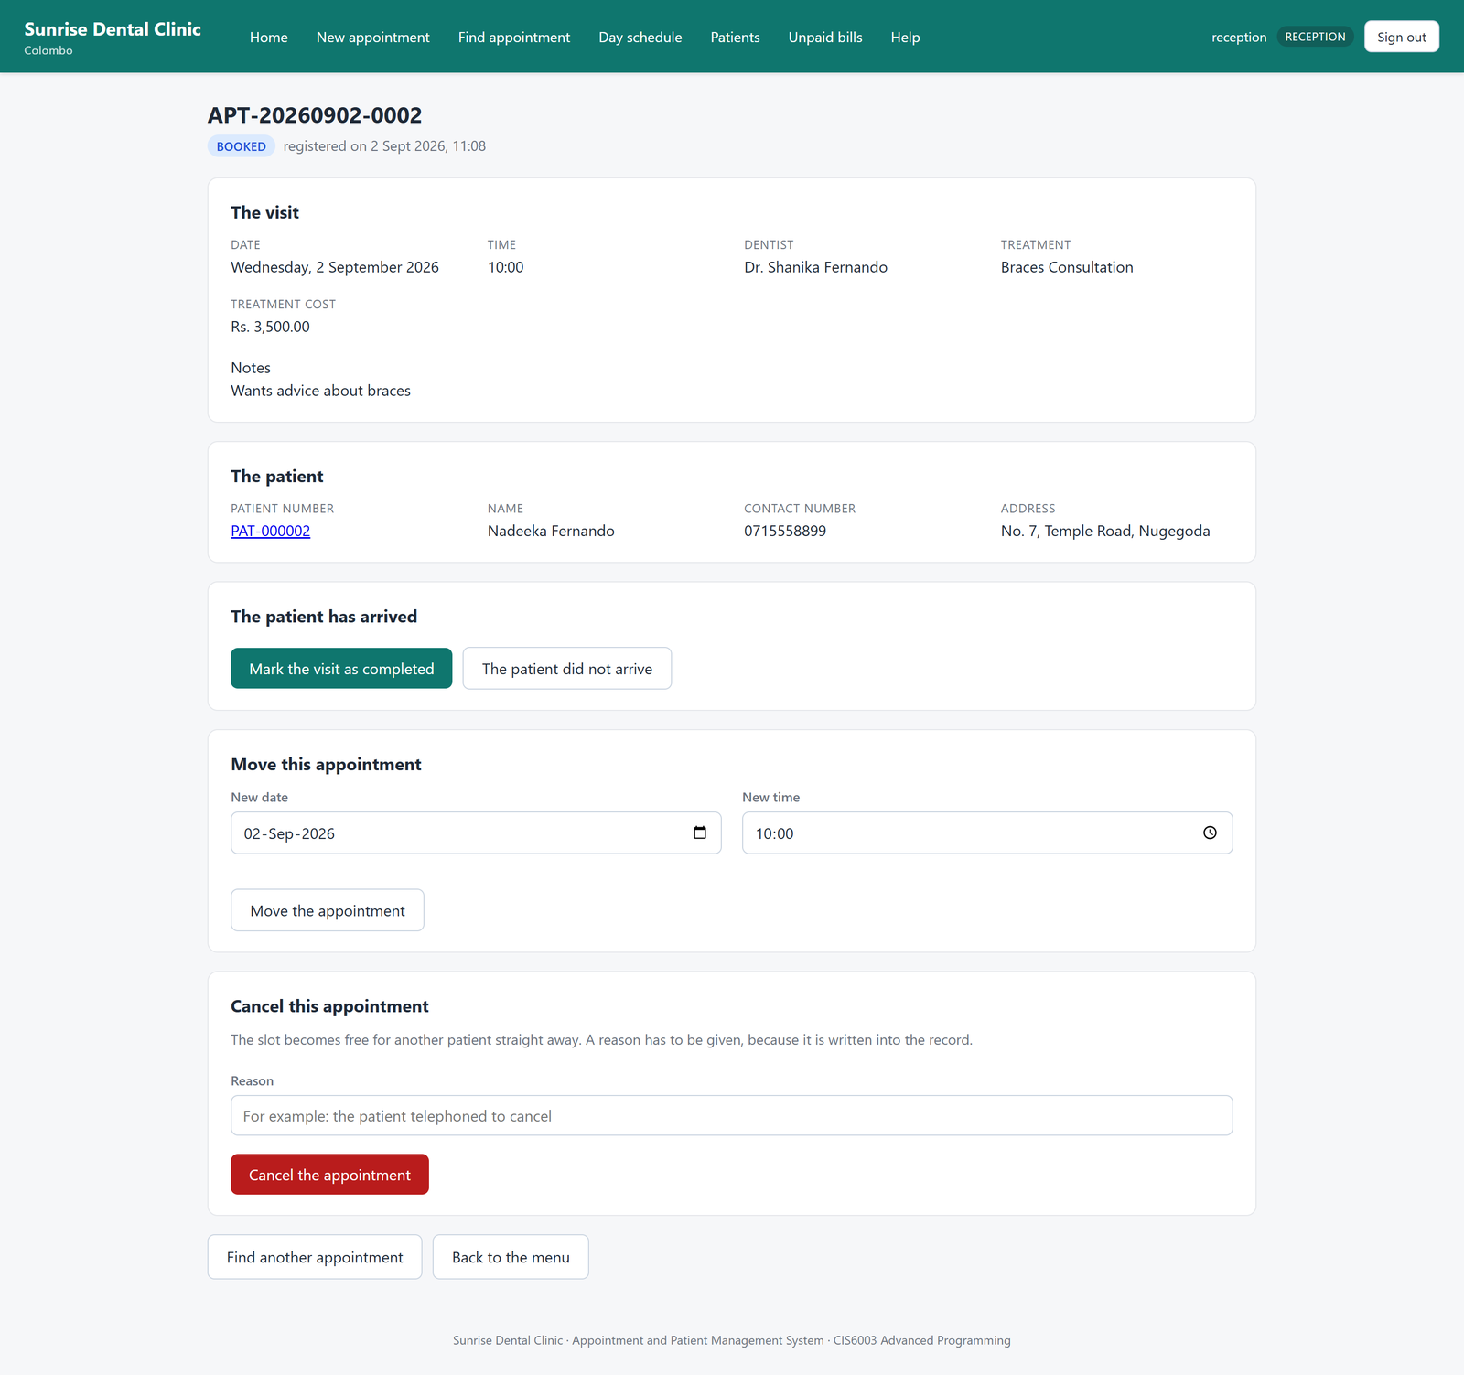
Figure 11: Appointment details
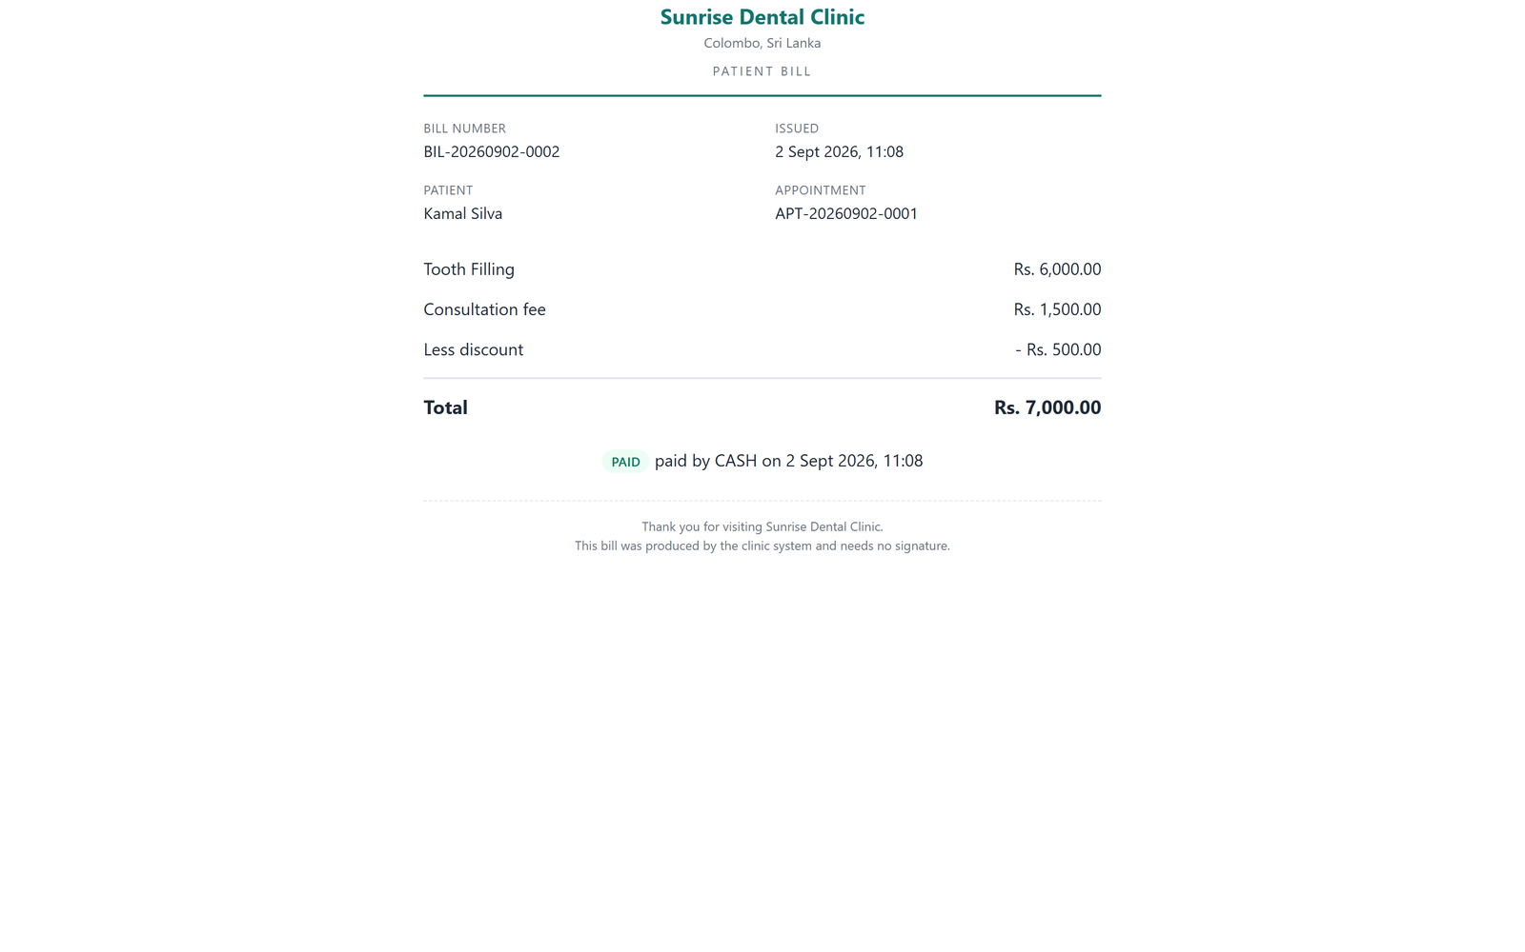
Figure 12: The printed bill
With 17 Thymeleaf pages using only one CSS file and only one navigation bar, all the jobs can be done with just one click as asked in the brief: menu driven approach. Home page (Figure 10) also presents the two numbers required by the front desk: total patients expected on that day and total amount due.
For data entry and result display we have two separate pages, as required by the assessment: registration page is appointments/register and the result page is appointments/view (Figure 11); billing page is bills/generate and bills/view. It is not a mere formality. Each save operation takes the user back to result page where pressing refresh reads the record again.
Figure 12 is a print layout, not the screen that has had the menu cut out; the print CSS leaves just the receipt, 6,000 + 1,500 – 500 = Rs. 7,000.00.
Additionally, the system offers a guide to using the website (FR5) and a way to log out (FR6) via a POST request with CSRF token.

3.7 Additional functionality delivered
In addition to FR1- FR6, 13 more features were implemented which included: cancellation and re-scheduling, treatment history, double booking avoidance, role based user access, three types of reports, unpaid bills, and appointment reminders.
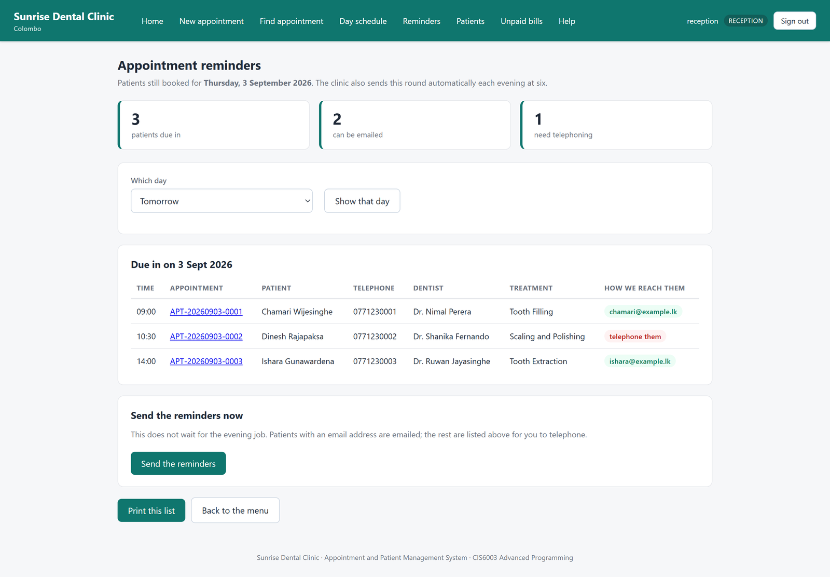
Figure 13: Appointment reminders
Reminder function (figure 13) returns two numbers of patients instead of one: number of patients contacted by e-mail and number of patients without e-mail address. "Five reminders sent" seems to be quite an easy statement if there were two patients that could not be contacted anyway. This gives the indication of the receptionist whom one should call on the phone the thing that computer cannot do.

4. Task C: Testing

4.1 Rationale for the testing approach
Level | What it tests | Count | Runs against | Speed
Unit | one class, collaborators mocked | 123 | nothing | milliseconds
Repository | JPA mappings and derived queries | 38 | in-memory H2 | ~1 s
Web slice | one controller, services mocked | 82 | nothing | ~1 s
Integration | the whole application context | 19 | H2, and a real port | ~10 s
Database | schema, procedures, triggers | 6 | real MySQL 8 | ~10 s

I have mostly positioned the tests at their best locations. The rules of the clinic change the most frequently, hence, 123 unit tests can be found at the level which will detect any error in less than one minute and does not require any installation. This quickness made me agree to run the suite after every small change, and any suite which I do not want to run is worthless.
While six database tests may seem to be much fewer compared to 123, the number does not matter. This set of tests includes what cannot be detected by any other level, and all the tests are slow since they require starting up the real MySQL. Adding more tests will not help and will make the suite too slow, thus, making me stop running it.

4.2 How test-driven development was used
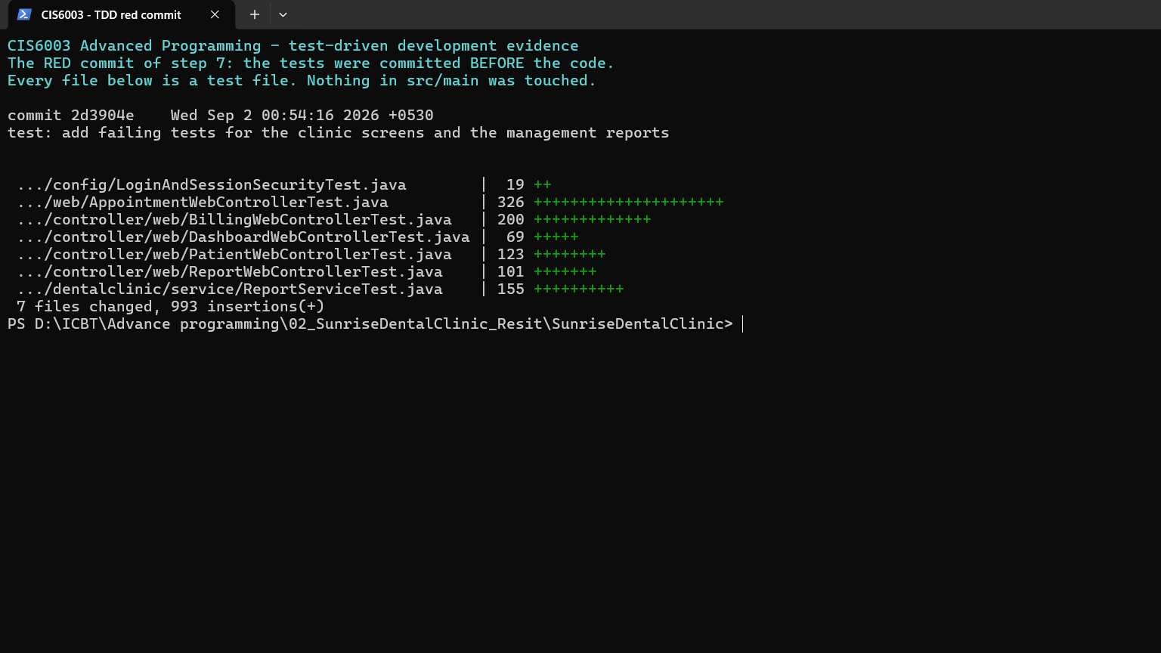
Figure 14: The red commit
TDD is not made out to be the case here; it is evident from the Git logs. In seven different instances over the course of four days, the failed tests are checked into the repository before the code that passes the tests. In all the red commits, none of the tested classes actually exists.
Step | Red commit | Green commit | Tests after
Domain model | 5c5c357 | a05f7c4 | 39
Design patterns | 2e89427 | dab3032 | 77
Service layer | 4fa3ebc | 49c5559 | 121
Web services | ca70acc | 1e07179 | 183
Security | a41b34b | 2e068c6 | 205
The screens | 2d3904e | ee29194 | 248
Reminders | 22e09fc | 7c8b027 | 262
All of them can be proved:
git show 2d3904e --stat # only test files
git checkout 2d3904e
mvnw test-compile # fails: cannot find symbol AppointmentWebController

The refactoring, which Beck (2002) identifies as the most frequently skipped stage, is also documented. The three pricing algorithms were initially developed as three separate classes, and all the tests for them were successful. Upon reviewing them, one would see that each had those three common steps, and therefore calculate() was extracted to an abstract superclass and marked final. None of the tests needed changing. This was how the refactoring became safe, and this was the exact purpose of the tests.
Two things that the red step introduced that need mentioning are these. Writing IsAllowedToday before the annotation made one think "Is today past or future?" and write @Past, which was right because a patient who complains about his teeth can come to you in the same day. The reason for writing FailingObserverDoesNotLoseTheBooking before IsObserverOnline is that we need to call every observer in a try.

4.3 Test plan and test data
Appendix B contains all the test cases: 111 of them, with ID number, preconditions, test steps, test data, expected/actual results, pass/fail status and the automation for the test case. All test cases were automated; no manual test cases were created.
Test data were created according to the specification (column width, working time, rules stated in the brief) and where necessary created in order to investigate the risks, using equivalence partitioning and boundary value analysis.
See Appendix B for some instances: 101 letters in a name versus the 100-letter column, one letter less in a telephone number, yesterday versus today, and the fourth visit versus the fifth visit based on the loyalty rule.
The most significant example is TC-DB-05, where the duplicate field gets inserted directly into the table through JdbcTemplate without any checks performed by Java. This is the sole way to confirm that a rule exists in the database, not just in the application.

4.4 Test automation and results
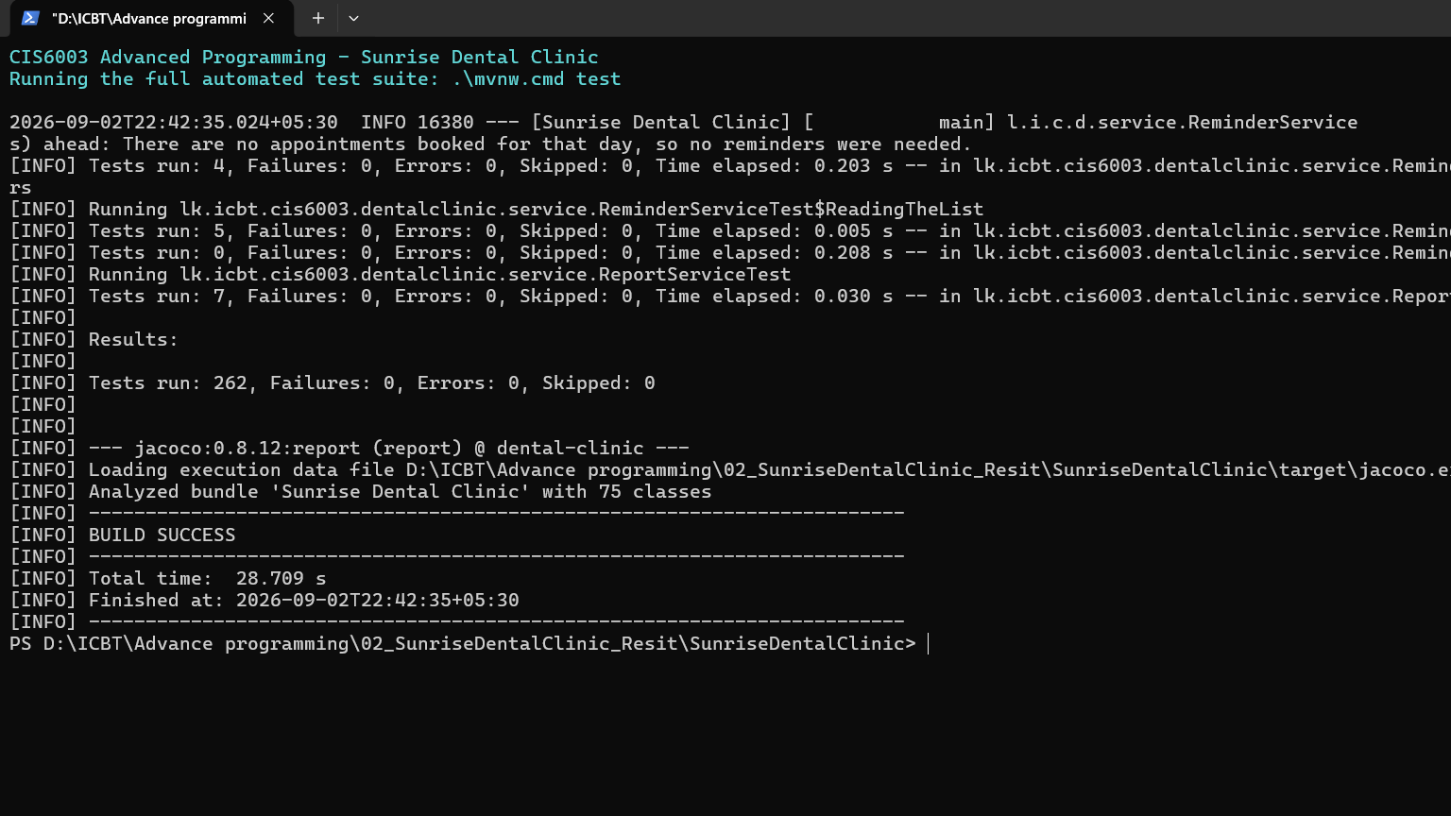
Figure 15: The suite passing
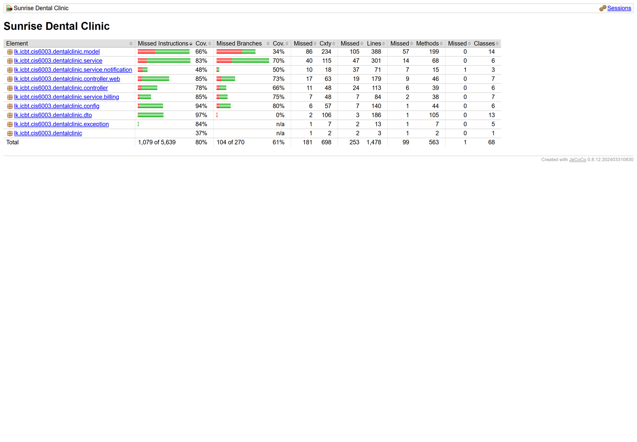
Figure 16: Coverage
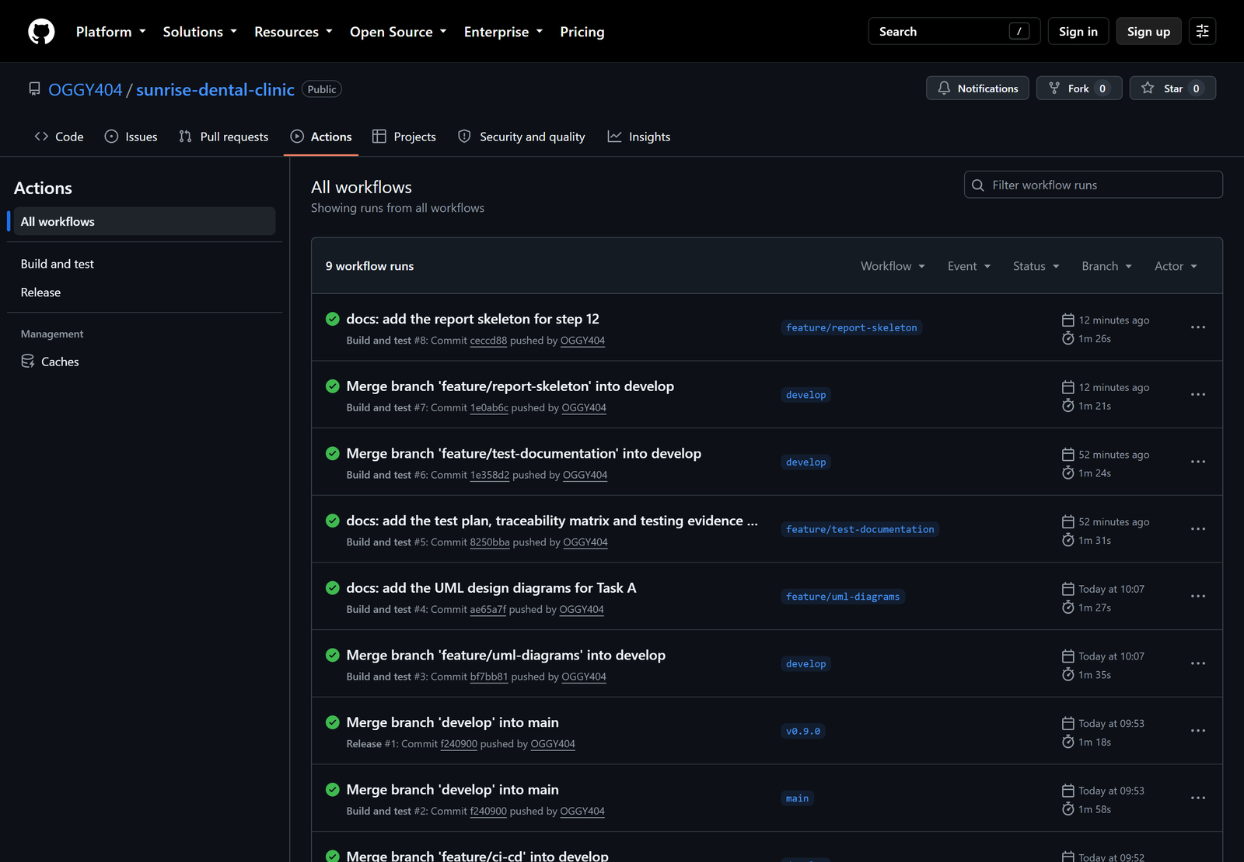
Figure 17: Continuous integration
268 automated tests in 32 test classes without a single failure (Figure 15). Coverage is 78.8 % instructions and 62.2 % branches according to JaCoCo (Figure 16). All this happens through a single command that requires no human intervention at all: ci.yml (Figure 17) executes the entire test suite on every push, reruns the database part with a real MySQL 8 container and builds the jar file if both tests succeeded.
Two numbers have been deliberately kept low. model is at 66.7% because most of it consists of accessors which are not invoked by any test, but those methods which make decisions are tested; service.notification is at 32.6% because emails are disabled till valid credentials are provided, and an increase in coverage will require mocking a mail server to test Spring’s ability to send emails.

4.5 Traceability matrix
Appendix C shows all the requirements from the design it is based on, to the implementation in the code, and from there to the testing process. If a requirement has no corresponding entry in the testing column, it has not been tested at all, but there is none like that. The six basic requirements are listed below:
FR1 requires nine tests, FR2 thirty, FR3 six, FR4 twenty, FR5 one, FR6 two, and all thirteen features of FR7 need forty-four tests.
There are three requirements that cannot be automated according to the matrix, which states that: printing on paper, sending an actual email, and the look of the interface. A matrix showing total coverage is misleading.

4.6 Evaluation and lessons learned
The test suite missed some items, and this is the most important thing that I have learned. Three bugs have been found in the working program with all tests passed.
Bug | Why every test passed
password_hash had been CHAR(60) in SQL but VARCHAR in the entity, thus the application could not start on MySQL | Tables are built by H2 from entities; therefore, they can never differ
The CSRF cookie was not issued again after deletion on logging in, hence all saves done after logging in would return 403 | MockMvc does not read the cookie but creates its own token
The two had been using different collations, so it was not possible to compare the parameter from the stored function to the column value. Every booking failed. | H2 has no stored functions at all

The problem in all three cases is the same: H2 and MockMvc were providing one side of the interaction and verifying the other side, hence the suite was validating its own assumptions rather than validating them.
I introduced two new layers in consequence: six tests using a real MySQL database, and two that would drive a real HTTP server with a real cookie, and I verified both of them by removing the fix and seeing them fail, which is the only way to make sure that a regression test works. The next time, I would have started my database tests in step 2, where the schema was created, rather than in step 9; an hour would have been enough to save all three bugs.
In retrospect, the practice of TDD was definitely a worthwhile one, though not necessarily for the reasons that I had imagined. TDD found less bugs than I had initially thought, but rather required me to think more carefully about how certain decisions were made, like the fact that todayIsAllowed had to be written before the annotation.

5. Task D: Git and GitHub

5.1 Repository and branching strategy
The public repository is https://github.com/OGGY404/sunrise-dental-clinic.
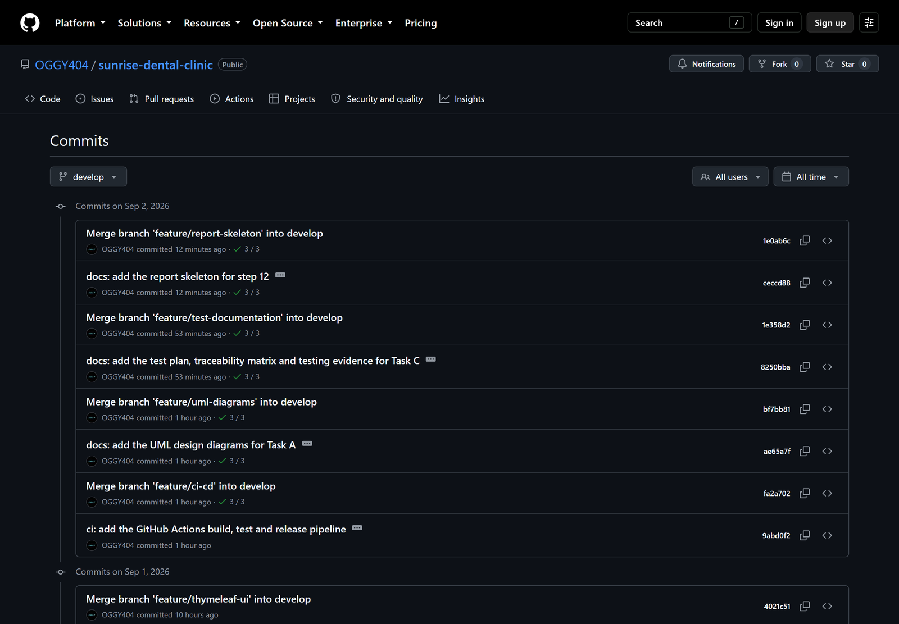
Figure 18: Commit history
Three-level branching approach was adopted:
- The main branch includes only the released versions and tags.
- The develop branch acts as an integration branch.
- The feature/* branch is divided into eleven branches based on the steps of the build process: database layer, UI, appointment reminders.
All feature branches were merged using --no-ff option; therefore, the history tree in Figure 18 displays the structure of the project, not a straight line.

5.2 Commits across multiple days
42 commits performed over four different days, with the implementation of one new feature per day: 6 on August 21st (repository, schema, procedures, triggers), 9 on August 28th (entities, patterns, services), 7 on September 1st (web services, validation, security) and 20 on September 2nd (screens, reports, CI/CD, UML, documentation and reminders).
Each commit uses the standard format (feat:, fix:, test:, ci:, docs:) and provides a justification instead of simply repeating the diff content. Test: commits intentionally precede their respective feat: commits, and that's the TDD proof from §4.2.
There is also a .gitignore file to exclude target/, IDE files, and .env from version control since there has never been any credential committed (only .env.example is committed).

5.3 Continuous integration and deployment
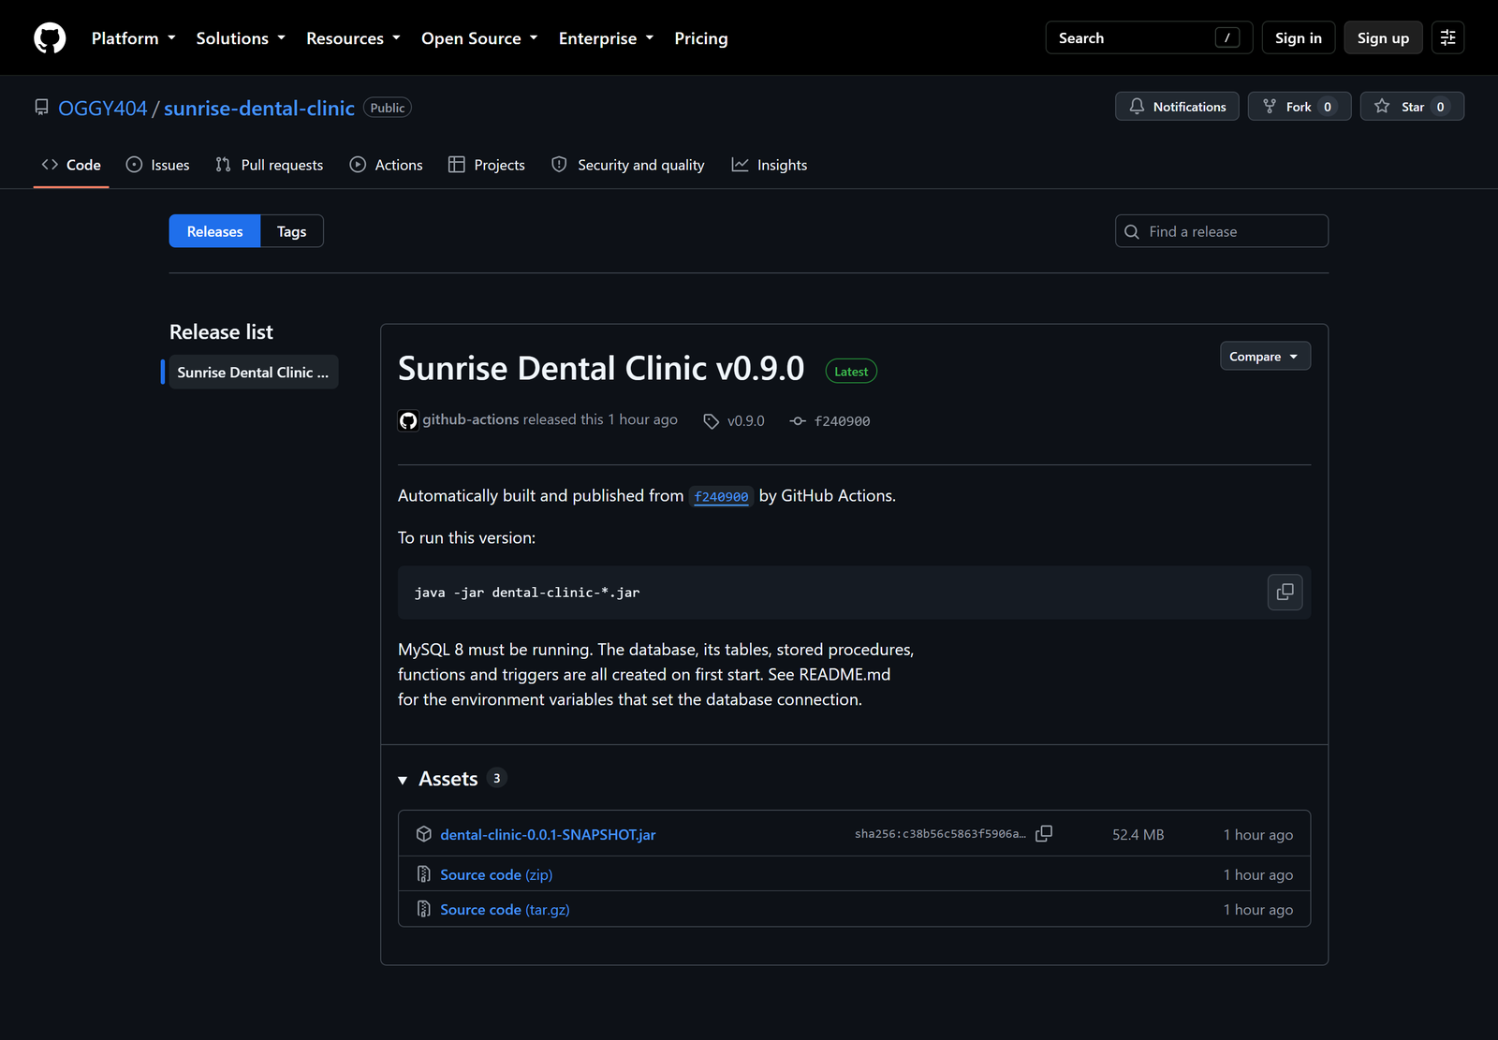
Figure 19: The release
ci.yml executes three jobs in sequence on each push/pull request: the 262 H2 tests, followed by the very same application using an actual MySQL 8 service container, and then the jar build, but only if the two former jobs pass successfully. The latter job is required due to the bugs mentioned in §4.6 – H2 corresponds only to the entity model it was created from, having no stored procedures, triggers, or generated columns.
release.yml is responsible for deployments. If a version tag is pushed, this will build from a fresh checkout and rerun the tests, as a tag could be pushed from any computer and a released version could never be an unverified version. It then releases the jar on a GitHub release. v0.9.0 is published with the jar included (see Figure 19). Since Spring Boot embeds the web server in the jar file, the deployment requires only Java 17, MySQL 8 and one command:
export DB_HOST=localhost DB_NAME=sunrise_dental DB_USERNAME=clinic DB_PASSWORD=...
export COOKIE_SECURE=true # once served over HTTPS
java -jar dental-clinic-0.0.1-SNAPSHOT.jar

The database, tables, functions and procedures will all be created automatically the first time the application starts, hence no setup is required for the new server.

6. Conclusion
The solution fulfills all six functional requirements plus 13 extra functionalities, validated by 268 automated tests, 8 UML diagrams and an automated pipeline that creates, tests and deploys a fully working product.
I am most proud that the double booking constraint is implemented within the database: no two receptionists could accidentally trigger a violation by saving at exactly the same time, and no Java code running outside the database could have provided such guarantee. What would have been changed is the constraint on treatment time, and starting the actual database testing much sooner.
The takeaway for me is more specific than “write tests”: a test proves nothing if it does not potentially disagree with your expectations.

References
- Gamma, E., Helm, R., Johnson, R. and Vlissides, J. (1994) Design Patterns: Elements of Reusable Object-Oriented Software. Reading, MA: Addison-Wesley.
- Fowler, M. (2002) Patterns of Enterprise Application Architecture. Boston, MA: Addison-Wesley.
- Beck, K. (2002) Test-Driven Development: By Example. Boston, MA: Addison-Wesley.
- VMware (2024a) Spring Framework Reference Documentation. Available at: https://docs.spring.io/spring-framework/reference/ (Accessed: 2 September 2026).
- VMware (2024b) Spring Security Reference. Available at: https://docs.spring.io/spring-security/reference/ (Accessed: 2 September 2026).
- Oracle (2024) MySQL 8.4 Reference Manual. Available at: https://dev.mysql.com/doc/refman/8.4/en/ (Accessed: 2 September 2026).
- OWASP (2024) Cross-Site Request Forgery Prevention Cheat Sheet. Available at: https://cheatsheetseries.owasp.org/ (Accessed: 2 September 2026).

Appendices
Appendix | Contents | Source
A | Source code listings of the key classes | src/main/java/...
B | Full test plan, 111 cases | docs/testing/test-plan.md
C | Full traceability matrix | docs/testing/traceability-matrix.md
D | All 17 documented assumptions | docs/uml/README.md
E | Sequence diagram 4: cancel an appointment | docs/uml/png/08-sequence-cancel-appointment.png
F | Remaining screenshots | docs/report/screenshots/
G | End-to-end walkthrough output | docs/testing/manual-walkthrough-output.txt
H | Database scripts | src/main/resources/db/*.sql
I | Full list of the 17 web service endpoints | README.md

